PROJECT-002 Add_Campaign Analysis
Problem Statement
Task 1:- Create a database: Add_Campaigns_Dev in
MY SQL workbench.
Task 2:- Create the tables
- Users
- Campaigns
- Ads
- Add Events
2: Perform the Problem Queries:
1. Find the top 3 ads per campaign based on number of clicks
2. Calculate daily CTR (Click Through Rate) for each campaign.
CTR = Total Clicks / Total Impressions
3. Find users whose click count is above the average clicks of all users.

4. Identify the campaign with the highest conversion rate (click → lead).
Conversion Rate = Leads / Clicks

5. Find the first interaction date for each user.

6. Find users who clicked on ads from more than one campaign.

7. Calculate running total of clicks per campaign ordered by date.

8. Find the day with highest impressions for each campaign.

9. Identify ads where clicks > impressions (data quality check).
Count clicks per ad
Count impressions per ad
Filter:

10. Find top 5 users with highest engagement score
(engagement = clicks + leads + opportunities).

11. Calculate percentage contribution of each campaign to total clicks.
% Contribution = campaign_clicks / total_clicks * 100

12. Find campaigns where no leads were generated.

13. Find users who viewed ads but never clicked.
Logic:
Users with impressions
Exclude users with clicks

14. Find the most popular ad type based on total interactions.

15. Calculate average time gap between user interactions.

16. Find campaigns where performance dropped (clicks decreased) compared to previous day.

17. Identify users with continuous activity for 3 consecutive days.

18. Find top performing campaign per location.

19. Calculate lead conversion rate per ad type.
Conversion Rate = Leads / Clicks

20. Find ads that contributed to at least 80% of total clicks
Count clicks per ad
Sort DESC
Calculate cumulative sum:
Divide by total clicks
Filter until ≤ 80%

21. Derive the Age Group based on age
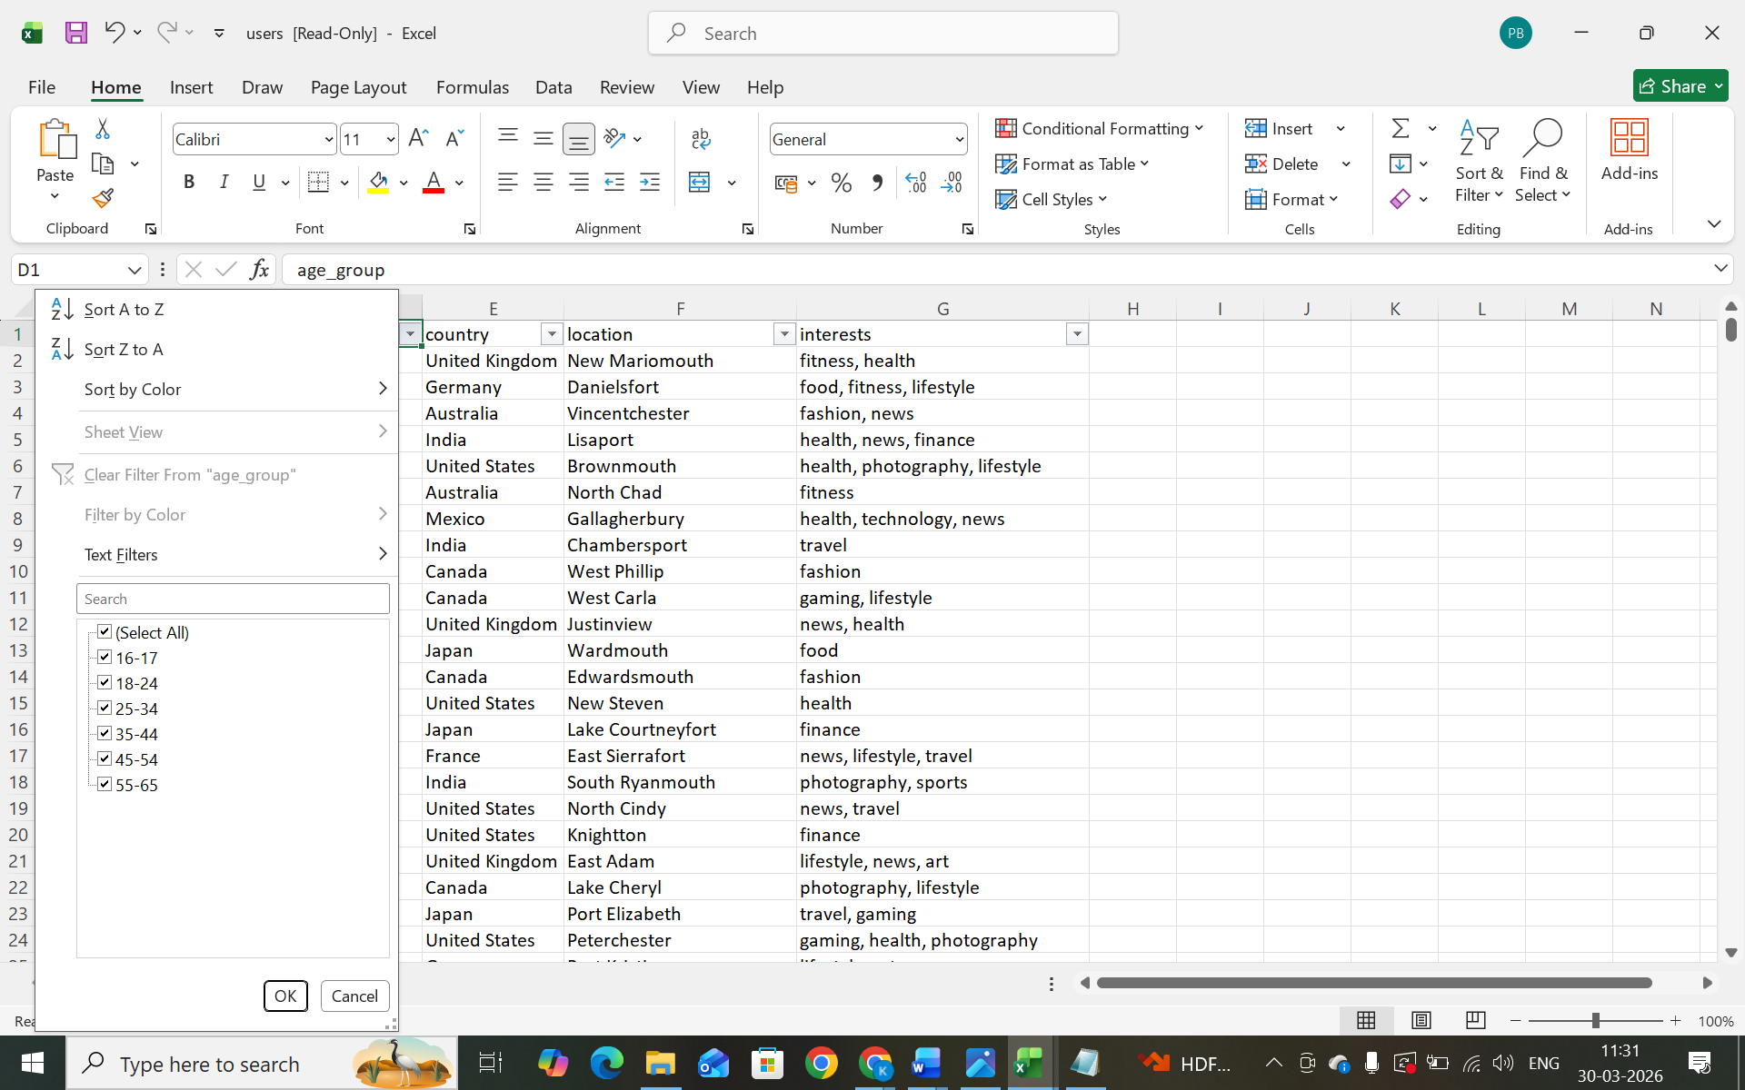
SQL Schema:
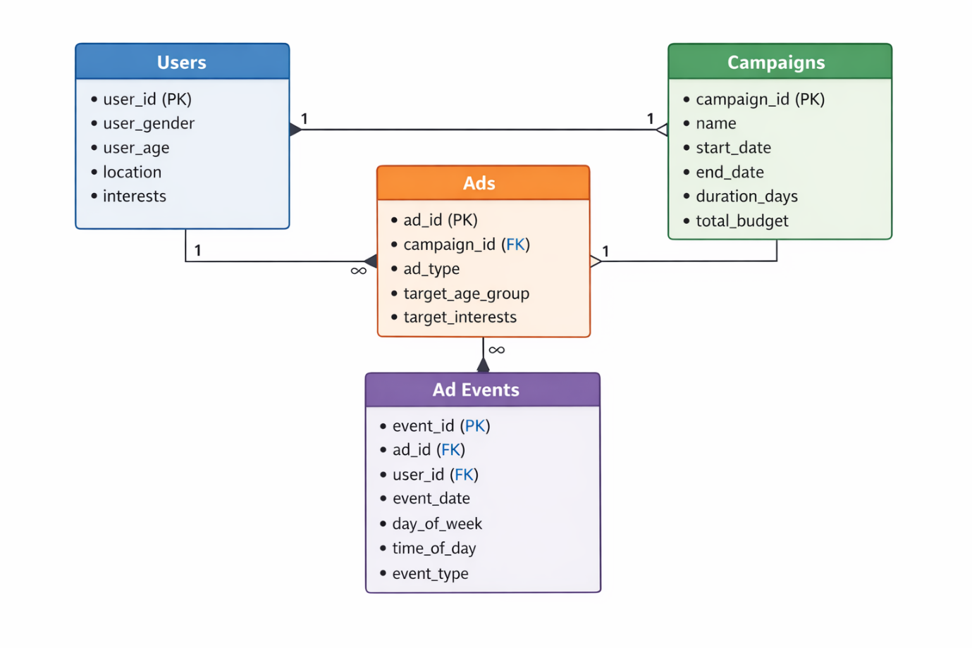

Report on Challenges faced:
Create a report which should include challenges you faced working on this project.
Submission Procedure:
Send .sql file
Prepare Unit testing document for all the scenarios.

